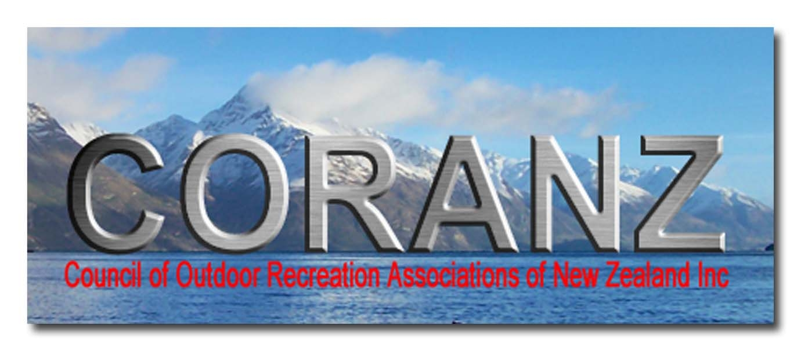
3 October 2010

Losing our Foreshore and Seabed –
National and the Maori Party’s new Foreshore and Seabed Bill

Do you know that the National government intends removing Crown ownership from the foreshore and seabed by the end of summer? This is effectively taking your property. It is virtually the giving away of a priceless public asset. The reason is simply politics and power. To retain its power base the National Government has agreed in return for Maori Party support in Parliament, to repeal the 2004 Foreshore and Seabed Act. That 2004 Act re-affirmed the Crown ownership that had been in place since 1840. The foreshore and seabed has been, and is at present, there for every New Zealander to use, enjoy and be responsible for.

The Crown foreshore and seabed is a massive area and contains very large amounts of natural resources. It includes all harbours and estuaries, and stretches 12 nautical miles (22.2 km) offshore from the nearest land. It is often called New Zealand’s Territorial Sea. It covers 10 million hectares (100,000 square Km), an area equal to more than 35% of New Zealand’s land area. It is probably the most popular area in New Zealand for outdoor recreation – fishing, boating yachting, underwater diving, swimming, surfing etc.

It is public property. Privatising even parts of it will adversely affect us all, just as privatising public dry land removes public rights.

National is removing Crown ownership because it blocks tribal ownership. Its removal will allow private Maori tribal ownership. Areas gaining customary title will be managed according to tribal custom. So other New Zealanders will be locked out of a meaningful say on management, on large areas of the foreshore and seabed that become customary title.

Christopher Finlayson, the Treaty Claims Minister and Attorney General, is driving the legislation. He is a former Ngai Tahu Treaty negotiator. He has publicly stated he expects 10% of the coast, 2,000 km, to gain customary title. Customary title is a very strong form of private property right, over which tribes will have control, including through the water and air columns above the seabed. They may also get trespass rights, especially where they define wahi tapu, and will be able to charge for public access, certainly for commercial access.

This legislation will be to the great detriment of all those New Zealanders. However it has not yet been passed. Public submissions on the bill, the Marine and Coastal Area (Takutai Moana) Bill, close on Friday 19 November. I describe below some of the major outrages in the Bill, and tell you what steps you can take to oppose it.

Race-based nature of the Bill:
The Bill is all about giving “rights” to small racial groups in our community – coastal tribes and sub-tribes, to the detriment of the rest of us. This includes Maori not associated with these tribes. It removes beneficial Crown ownership. Most coastal tribal leaders have said they want full customary title ownership of all the ten million hectares of the foreshore and seabed. Hone Harawira is the most vocal. But most other Iwi Leaders have a similar position.

Three iwi property rights, not just one:
National proposes three iwi property rights with increasing private property rights:

mana tuku iho (Ancestor recognition – Clauses 49-52) – this will automatically be allocated to coastal tribes according to the coast they claim under the 2004 Maori Fisheries Act, through the Te Ohu Kaimoana Trust. It covers the whole 10 million hectares of currently Crown-owned foreshore and seabed, and is similar to the coastal areas controlled by these tribes in 1840. Rights attached include the Department of Conservation having to specifically notify and “have particular regard” to the Group’s views on - marine reserves, marine mammal sanctuaries, concessions etc. Thus ferry services to Kapiti Island or elsewhere, could be dropped in favour of a solely iwi boat, with consequent increases in fares because it would be a monopoly.

Protected customary right (Clauses 53-59) – said to protect traditional customary activities such as gathering hangi stones, launching waka. Has to have ben exercised since 1840, and has not been extinguished by law. No need for ownership of adjacent land or resource consents

Customary marine title (Clauses 60-91) – a very strong property ownership right, including “wahi tapu” rights that exclude the public. Gives monopoly rights to mining, aquaculture, and any new facilities in their area. They have veto rights on anyone else wanting to undertake these activities, and likely transfer of any current facilities eg wharves, boat launching ramps, marinas etc to the group on expiry of their current coastal permits. They also get payment of government mineral royalties on mining activities in their area, from the date of their application.

Conditions for award of this property right are set out in the Bill, and are significantly lower than in the 2004 Act. Definition of the conditions bypasses any debate about whether such rights existed in 1840, before British law was introduced. Given no tribes included confiscation of the foreshore and seabed in their Treaty claims prior to 2003, it is clear iwi didn’t see this as a confiscated property right until the Court of Appeal decided that it may exist, in its controversial Ngati Apa decision in 2003.

The tribal group has to prove it has had exclusive use and occupation of its area, from 1840 to the present day without substantial interruption, and have held the area according to Maori custom. Customary transfers may now also be included.

These property rights are only available to tribes, sub-tribes or Maori whanau able to negotiate successfully with the Minister. They are not available to any other New Zealanders, and cannot be sold, though they can be leased by agreement. The rights are a twenty first century Maori interpretation of the rights they believe they should wield and have little to do with the customary rights of 1840.

Free public access not guaranteed:
Though Minister Finlayson wants you to believe public access will be guaranteed, this will not be the case. First section 40 (b) of Labour’s 2004 Act that specified charging or collecting fees, or other form of payment, for use or occupation is prohibited. It is very significant that Finlayson did not transfer this section across, though he did transfer many other sections. The Bill contains no penalties for charging for access or prohibiting it. As well, under the Fisheries Act, the non-tribal public can be excluded from fishing in a mataitai. Expect mataitai to also sprout around your favourite fishing areas.

Already, at Ahipara at the bottom of Ninety Mile Beach, a sub-tribe is attempting to charge commercial tour operators for access to the outstanding surf break at Shipwreck Bay. Minister Finlayson sees this as “just and fair”, highlighting his true intention to allow tribes to charge for public access, or even prohibit it.

Tribes with Customary title can charge an iwi-tax on a commercial activity in their area, or clip the ticket. They can also veto its continuation, run the activity themselves, or charge a concessionaire, as they do on Mt Tarawera or on the Maori land in the Kaimanawa Ranges etc. Expect various ingenuous ways being thought up by tribes to charge the public or clip the ticket.

Fishing charter boats fishing a customary title area, as a business activity, would be highly likely to be levied a tribal tax for doing so. This of course would be paid directly or indirectly by the fishers on board. Also, the operation could be vetoed, or be sub-let to another operator, if the present operator fell out of favour with the tribe.

Wahi tapu (sacred) sites:
Wahi tapu are of very great concern, as these are areas where the public is excluded. These are defined broadly as “sacred places”. Usually burial areas are mentioned. But the definition can be far wider than that eg sacred waters. There are no registered wahi tapu anywhere at sea at present. None have been created since 1840.

Finlayson intends that they will be defined solely by the applicant group and himself in secret, with no input from the public, or even other tribes. So they can be anything the applicant group and the Minister agree on. Because the Minister’s decisions will be unchallengeable, they are likely to become extreme. They are best looked as a Trespass Rights card awarded by the Minister, and his recognition of the group’s tino rangitiratanga (Maori sovereignty).

Wardens are provided for to patrol wahi tapu sites in the Bill. Fines of up to $5,000 can be imposed for entering a wahi tapu area. In New Zealand, Maori cemeteries are usually open to the public. Even famous battle grounds eg Gallipoli, Normandy landings, the Somme etc where tens even hundreds of thousands of men were slaughtered, are usually open to the public. Wahi tapu rights seem simply a reason given to tribes to be able to exclude the public, and show them who is boss. After 170 years of the public having access under Crown ownership, that will be an extreme power to give to tribes.

Why would Maori want to keep people out of wahi tapu areas? This is especially the case given the public has had free access to them under Crown ownership, since at least 1840, and probably before. Mr Finlayson seems to be trying too hard to please Maori tino-rangitiratanga separatists, and the Maori Party, and forgetting he is supposed to be representing the interests of the public of New Zealand.

Corrupt processes proposed for decisions on tribal customary title:
The most unsatisfactory thing about the proposed process of awarding customary title is that it can be done by “recognition by agreement” (Clauses 93-95 of the Bill) with the Minister in secret, with no other alternative interests or opponents present, and with no cross examination, rather than in the High Court, where opponents can have a say, and where evidence can be tested by cross examination.

This process leads to an Order in Council. This Order only needs to identify the group and the area. It is not required to release information showing the conditions of title are met. Nor is any process set out in the bill for challenging these secret decisions.

Even National Government MPs seem poorly briefed about these provisions. At a public meeting on the Bill in Taranaki, National MP Chester Borrows tried to tell the meeting that no such “by agreement” process existed. He didn’t get away with it. Don’t get misled when poorly, or wrongly, briefed MPs stretch the truth like this.

Award can also be by an Act eg a Treaty claim process, whereby, again involvement of the public interest would be effectively avoided, as it is with all Treaty Claim processes. Especially dodgy cases could be dealt with in this way, as there is no requirement that such new Acts meet the requirements of this Bill. In any case it is not possible for current legislation to bind future legislation.

Although an alternative High Court process is defined in great detail (Clauses 96 – 117), don’t be misled. It is a red herring. No tribal group in their right mind would go to court, with all the expense and risk that entails, when they can achieve much more by secret meetings with a friendly Minister. At present, that Minister is Christopher Finlayson, who has taken note almost solely of tribal wish lists, and has a long history of opposing the Crown in Ngai Tahu Treaty Claims. But it could just as easily be Pita Sharples, Tau Henare, or Hone Harawira. Think about it!

National’s hypocrisy about tribes “having their day in Court”
National’s Minister Christopher Finlayson has talked excessively about the need for tribes to “have their day in court” to prove customary title. You can see from the above that this Bill has been written so that this will never happen. This is yet another example of Finlayson’s hypocrisy.

So the strong arguments against National’s proposals, such as how the Maori sign of land ownership, fires of occupation, could take place on the foreshore and seabed in 1840, and how tribes could occupy ie live on, the seabed, down to the deepest parts of the ocean, will not be tested in court by opponents. They will lose their “day in court” too, through Finlayson’s Bill.

There is also the matter of why tribes can claim customary title out to 12 nautical miles, when in 1840 New Zealand’s territorial sea only went out three nautical miles. It wasn’t till the 1977 New Zealand Territorial Sea Act that the territorial sea was extended to 12 nautical miles, quadrupling its area. These are gains that should accrue to all New Zealanders, not be stolen by Maori tribes, and create a very divisive issue in our society.

Can you trust the Attorney General?:
Christopher Finlayson, who also holds the Cabinet position of Attorney General, is the extreme hawk in John Key’s National Cabinet when it comes to Maori privilege, and disposing of public land. This probably comes from his long association with Ngai Tahu, one of the most aggressive tribes with regard to wanting ownership of the foreshore and seabed.

He was the one who wanted to give the 212,000 hectare Urewera National Park to Tuhoe, as part of their Treaty Claim last May. He was only over ruled by Prime Minister John Key from this extreme and unjustified give-away. Unfortunately Key seems to be blind to the much more divisive issue of giving away New Zealanders’ five hundred times larger foreshore and seabed.

What you can do to help stop this race-based privatisation!
I urge you to help stop or slow down this race-based privatisation of our foreshore and seabed. Consider helping by doing the following:

- Make a submission on the Bill: Express your concern to Parliament about the Bill by Friday 19 November 2010.

Even a short submission is worth making.

If you have never made a submission before, this is a good time to start. If you wish, ask to be heard in support of your submission. This adds weight to what you have written, and allows discourse with the Committee, that may clarify issues for them. Be prepared to stand up for your views though. The Select Committee will be travelling widely to hear submissions.

The Coastal Coalition, www.CoastalCoalition.co.nz has information on making submissions on its website, as will the Council of Outdoor Recreation Associations www.coranz.org.nz

Submissions should be sent to: Suze Jones, Secretary, Maori Affairs Select Committee
Suze.Jones@Parliament.govt.nz or posted to Maori Affairs Select Committee, Parliament, Wellington (No stamp required).

- Tell friends, acquaintances, eg your club members and others about the extremes and injustices against the public in this Bill

- Write a letter to your local paper – an effective way to tell thousands of others

- Talk to your electorate MP, especially National MPs, about the extremely divisive and unfair nature of the Bill they are hoisting on the public without a mandate. National did not tell the public about this before the 2008 election.

- Read my just-released book on the issue The Gathering Storm over the Foreshore and Seabed- Why it must remain in Crown Ownership, by sending $20/copy to Tross Publishing, PO Box 22-143 Khandallah, Wellington 6441; or by emailing trosspublishing@hotmail.co.nz

- Support the Coastal Coalition in fighting this extreme race-based legislation by making a donation at www.CoastalCoalition.co.nz

If the public don’t respond actively we are likely to lose the public foreshore and seabed to tribalism and tino rangatiratanga forever.

Best regards

Dr Hugh Barr, hugh@infosmart.co.nz
Secretary, Council of Outdoor Recreation Associations

