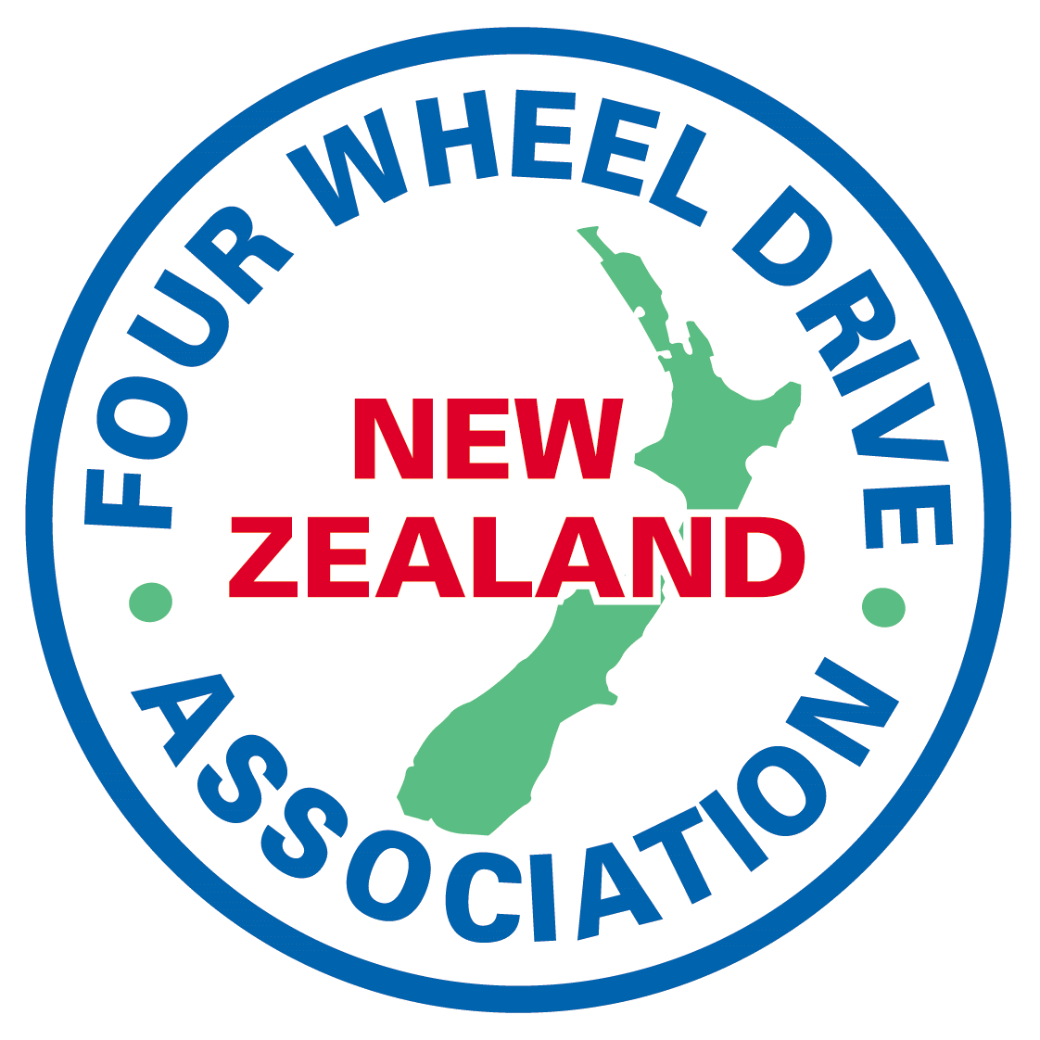
SUBMISSION TO NZTA ON THE
RESHAPING STREETS
PROPOSALS

INTRODUCTION
The New Zealand Four Wheel Drive Association represents some 2200 members across New Zealand and a number of Member Clubs in Auckland.
The Association notes that the changes being proposed stem from the intention of the Minister of Transport.
The Minister of Transport is proposing a set of regulatory changes to make it easier for local authorities (like councils) to make street changes that support public transport, active travel and placemaking.
The Association submits that the changes and powers being created should be designed and limited to do just that, no more, no less.
The Association has no objection to the expressed intent of the changes regarding the “reshaping” of streets in so far as the examples provided concerning urban malls, school streets, play streets, community streets and the like.
The Association does not support the extension of the powers that are being created, ostensibly for the above purposes which are all designed around urban areas, but are in fact applicable to a much greater range of legal roads, be they formed or unformed.
The Association makes considerable use of Unformed Legal Roads (ULR) throughout New Zealand, be they in forests, beaches, or elsewhere. There are established Court decisions that support the right to pass and repass on such legal roads, as well as established procedures in Acts and Regulations requiring consultation should a RCA propose restrictions on such legal roads.
The Association submits that the proposals should be targeted at the areas of roadway necessary to effect the wider changes sought and therefore the powers should be restricted to URBAN STREETS. The powers should not apply to areas of ULR.

SPECIFIC AREAS OF CONCERN
The Draft provides for:
Road controlling authority may change the use of roadways
A road controlling authority that is a local authority, government department or Crown entity may, in accordance with this Rule, take any of the following actions in relation to a roadway that it controls:
(a) prohibit or restrict the use of motor vehicles, or one or more classes of motor vehicle, on the roadway:

The Association opposes the breadth of this proposal as it is far wider than necessary to achieve the stated purposes relating to urban streets.
This effectively gives a RCA a power to permanently close a legal road (without a Road Stopping process), or to limit, say 4WD vehicles on all or any parts of such roads. The limitations of purposes in section (3) are particularly broad and can obviously be used to achieve any particular road change desired, irrespective of the strength of evidence supporting a particular rationale.

The rule also allows for a RCA to”
(f) install or remove modal filters.

Again, the Association does not support a wide power as proposed and if applied in other than urban streets can include bollards and blocks restricting vehicles, but allowing other uses, which is again effectively a vehicular road closure
CONCLUSION
The Associations submission can be best met by a limitation to the purposes intended by the Minister and it submits this can be achieved with no other detriment by including, in the draft Land Transport Rule: Street Layouts 2022. the word “formed” before roadway in both the Objective Section 1.3 (a) (twice) and in Section 2.1 (1).

Ian Hutchings
National Land Access Officer
For NZ Four Wheel Drive Association
Landaccess@nzfwda.org.nz

